Supporting Information

Title
Long nanoneedle-electrode devices for extracellular and intracellular recording in vivo

Yoshihiro Kubota¹, Shota Yamagiwa¹, Hirohito Sawahata¹, Shinnosuke Idogawa¹, Shuhei Tsuruhara¹, Rika Numano^{2, 3}, Kowa Koida^{3, 4} Makoto Ishida^{1, 2} and Takeshi Kawano¹

HF after aqua regia treatment of the needle’s tip
In order to achieve penetration of a silicon microneedle into a cell, it is necessary to form nanoscale geometry at the tip of the needle. The nanoscale tip can be formed by exposure of the needle to aqua regia followed by subsequent HF treatment (Fig. S1a). Aqua regia both removes the gold–silicon alloy at the tip of the needle and promotes the chemical oxidation of silicon microneedle. The oxidized silicon layer (silicon dioxide) is then etched by subsequent HF treatment, resulting in a nanoscale-tipped silicon microneedle (Fig. S1b).

Device layout of NTE array device
Fig. S2 shows the cross-sectional and top view schematics of an NTE, with the interconnection and the layout of two interconnections (platinum and titanium multiplied layer) in the array. The length and width of each interconnection are ~8.26 µm and 30–60 µm, respectively, and the thickness is 200 nm. The nearest-neighbor interconnections in the array are 30–60 µm apart. The surface of each interconnection is covered with <1-µm-thick parylene-C. Underneath the platinum–titanium interconnections is 5-µm-thick silicon dioxide (buried oxide of the silicon-on-insulator substrate).

Intracellular recording via a glass pipette
We also confirmed resting membrane potential–induced voltage changes by introducing a glass pipette into cells. Fig. S3a shows the SEM image of the glass pipette, which had a tip diameter of ~800 nm. The recording system (amplifier and data acquisition system) was the same as those used for NTE devices (see “2.4 In vivo recordings”, in Methods). The glass pipette was placed on exposed primary somatosensory cortex (S1B) of a mouse, and then penetrated the brain tissue (Fig. S3b). Potential changes of ~50 mV were observed after glass pipette penetration (four trials) (Figure S3c).

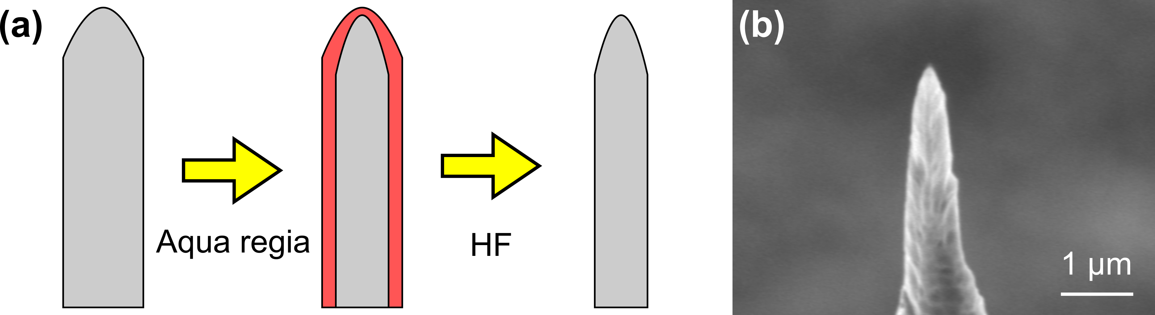
Fig. S1

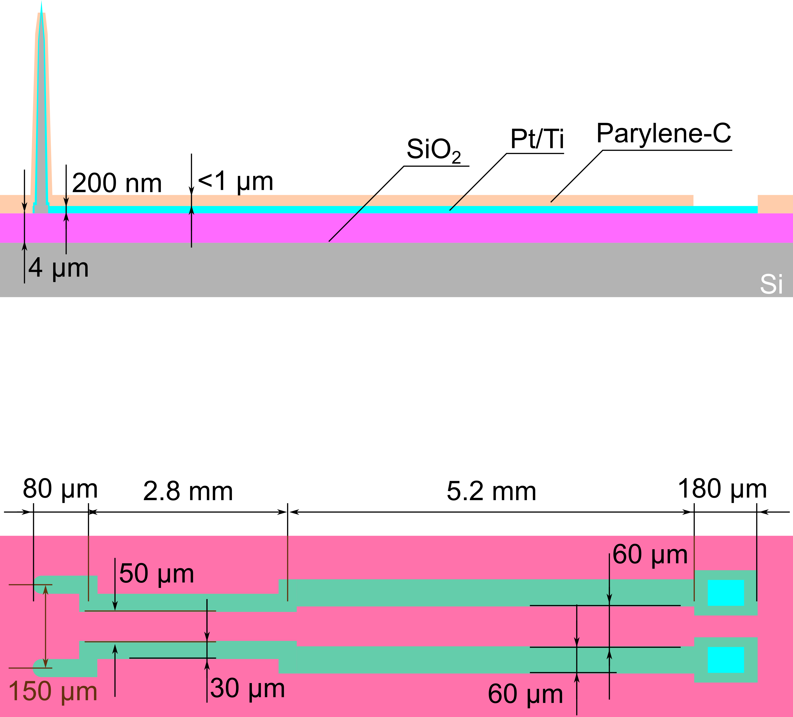
Fig. S2

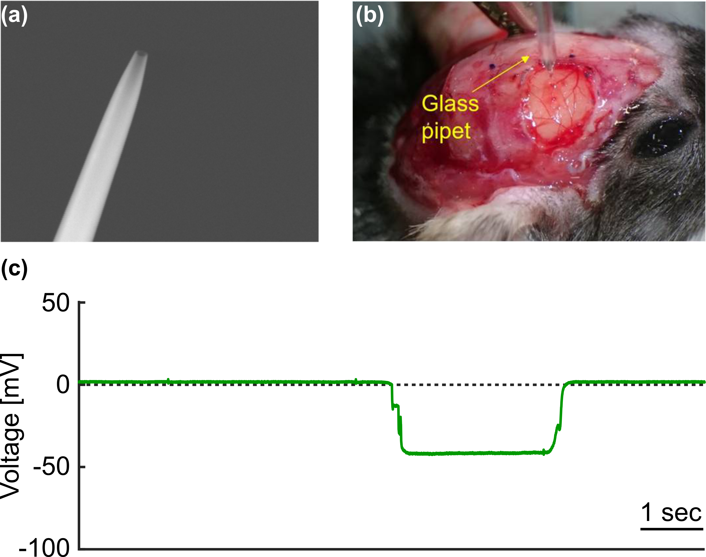
Fig. S3

